The Newton Colour Circle:
This is a convenient way to summarize the additive mixing properties of colours. The primary colours, red, green and
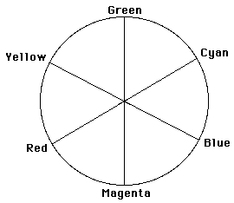

blue, are arranged around the
circumference of the circle 120º apart.
Their complementary colours are placed
opposite them on the circle. A line joining
any two colours on the circumference of
the circle passes through all the colours
which can be formed by mixing those two
colours. For example, mixing green and
red in equal amounts produces yellow.
The yellow produced in this way will be
less saturated than the green and red
which formed it as it is closer to the
circle’s centre. Mixing two colours opposite each other in equal amounts will produce white.

The Munsell Colour System:
The munsell colour system
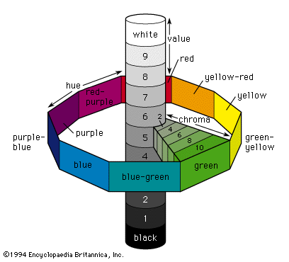
takes the Newton colour circle
and divides the hue into 100
equal divisions. The circle is
distorted however by the
fact that different hues are
allowed different levels of
saturation. For example, there may be 10 perceptible saturation levels for green, but 18 for red. Perpendicular to the plane formed by hue and saturation is the brightness scale. Any point in the colour space may be specified by hue, saturation, and brightness.

The Ostwald Colour System:
The Ostwald system creates a colour space based on dominant wavelength, purity, and luminance, by mapping the values of hue,
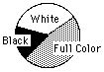
saturation and brightness. Establishing the values for
these parameters is done with a disc colorimeter which
mixes on a disk amounts of the pure spectral colour at
the dominant wavelength with white, and black . Thus
a point in the Ostwald colour space is specified by
the values C, W and B, which represent the
percentages of the circle occupied by the spectral colour, white and black respectively. For example 35, 15, 50 represents 35% full colour, 15% white, and 50% black.

